Populations and Ecosystems test #2: Name __________________________________________ Period ____
- At the beach, students observed and recorded the following interactions in their journal:
- Crabs were found eating small flies.
- Crabs, sea snails, and fish were harder to find after a flock of sea gulls came to the beach.
- Fish would swim up and eat the little flies that landed on the surface of the water.
- There were more sea snails and flies present when the amount of algae increased on the rocks.
- The level of bacteria in the water increases when pollution causes organisms to die.
Use the above information to create a tiered food web:
- Correctly place the names of the organisms into the boxes provided.
- Correctly draw all needed arrows.
- Label the tiers of the food web on the lines provided.

- How much energy is passed on at each trophic level? __________________________________% (1pt)
- Name 2 ways that organisms use energy that is not passed onto the next trophic level. _________________________________ and ___________________________________ (2pts)
- How do plants get the energy they need? ______________________________________________(1pt)
- How do animals get the energy they need? _____________________________________________(1pt)
- Plants need ______________________, ____________________ and ______________________ to photosynthesize. (3pts)
- Plants use photosynthesis to make ______________________________.(1pt)
- List 2 limiting factors in the Arctic ecosystem. Explain what population it limits and how it limits that population. (4 pts)
Limiting factor #1 ______________________________________________________________________
_____________________________________________________________________________________
Limiting factor #2 ______________________________________________________________________
_____________________________________________________________________________________
- Describe 1 interaction involving the polar Bear. (biotic or abiotic) (2pts)
_____________________________________________________________________________________

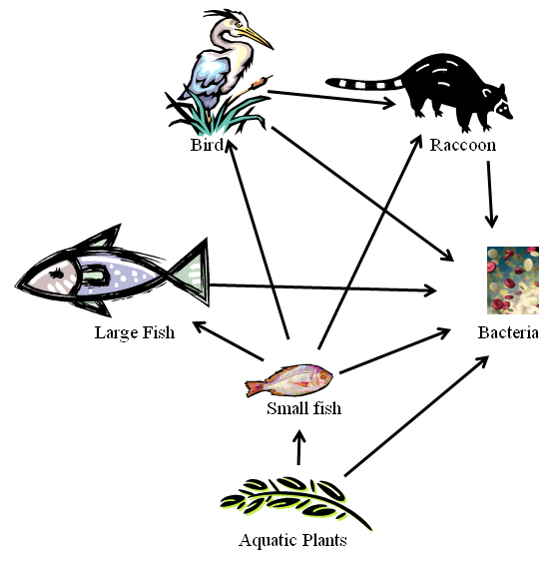
Use the above food web to complete the following table. Some organisms may be listed in more than one category. Write the name of each organism in all appropriate categories.
Trophic Level | Organism(s)
Producers
Primary (1st-level) Consumers
Secondary (2nd-level) Consumers
Tertiary (3rd –level) Consumers
Decomposers

